Proposal for FC&PA’s Administration of MAF and MAEF
During my interview process, it was mentioned that the President of FC&PA would likely also be acting as the President of MAF and MAEF. I have also been shown a chart that shows how the industry thought actions and responsibilities would be divided over the groups. Over the last few weeks, I have had discussions with Jerry Painter as Chairman of MAF, Robert Carlton as Chairman of MAEF, and many others. After also discussing this with many of you, I would like to offer a proposal to address this issue.
First, there is the question of titles. I had concerns about having the President of FC&PA also be President of these other groups. To do this, By-Laws would need to change, and I also wondered if we could do this given that FC&PA is a 501C6, and MAEF is a 501C3. I consulted with David Ramba on the legality of this, and he expressed that the best and most expedient way to handle is to have the FC&PA act as the “Association Manager” of the others, with contractual agreements stating as such and spelling out specific scopes of work.
So I have laid out staffing needs (see below and attached as separate sheet) and scopes of work for the organizations. I do think that the shared staff will enable all 3 associations to run at the highest efficiency.
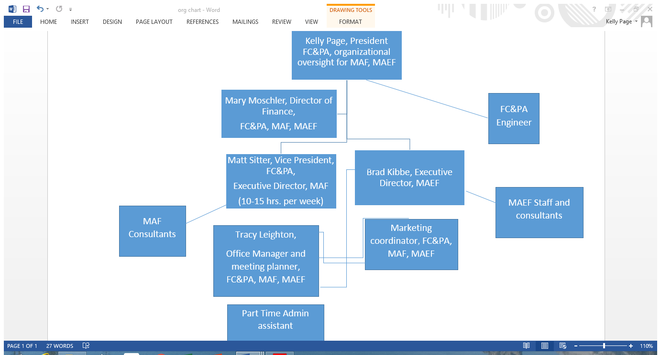

MAF
In my opinion, the MAF only needs an Executive Director about 10-15 hours per week to manage what they currently have. There are several reasons for putting Matt Sitter in this role. First, the promotion campaign for block closely aligns with MAF’s mission, so to have the person in charge of it for FC&PA also be in charge of the MAF makes sense. The campaign can align more closely with what ProMasonry is doing, and take advantage of the large architect database that they have built. The MAF ProMasonry group and the FC&PA campaign should be aligned and working in concert to get the most efficiency of the dollars being spent in both groups.
Currently, only Deb Bartolucci and Aaron Bettinger are on the MAF payroll, Deb for 30 hours per week (she also is on the MAEF payroll for 10 hours per week, thus making her full-time between the two organizations), and Aaron for approx. 18 hours per week, and this seems to vary. Don Beers is a consultant and not on the payroll. My plan would be to have staff in Orlando take over the majority of Deb’s duties. Tracy Leighton would manage their convention, the new marketing person would take over her marketing responsibilities, and the admin would pick up any other work. To ease the transition, I would leave $10,000 in next year’s MAF budget to hire Deb for specific projects, with timelines and end results. I would much rather have all of the staff in the office in Orlando working as a team. I think having all staff (with the exception of the consultant) in Orlando is the best way to oversee everyone, and ensure that they are meeting their goals.
Our goal is to work with the members to be successful enough to make MAF much more robust and viable, especially financially, than it is currently, which would be the best outcome for the industry.

MAEF
MAEF is in somewhat better shape with leadership than MAF. Brad Kibbe is currently the Director of Masonry Apprenticeship, and thus spends all of his time fulfilling this role. He needs to be named Executive Director of the Foundation, which will change up his duties somewhat. This will have him in the office at least a day or two every week, so there will be closer oversight on what he and his staff are doing. He has been working on getting expenses down, and requiring more reports from his staff, but I think there is still more that can be done. MAEF has 6 people on the payroll: Brad Kibbe, Deb Bartolucci, Sandy Cinque, Al Herndon, Donna Hinson and Julio Vasquez. Dennis Neal is a consultant. Payroll is by far their biggest expense.
Brad knows the educational system in the state very well, but is learning about running an association. I think with some oversight, he could do a good job with MAEF.
I have also met with Robert Carlton, the current Chairman, and with Brad Kibbe multiple times, to discuss how to better use the funds they receive to create more masons (not necessarily more apprentices). Again, I have heard much frustration that the current apprentice program does not seem to be working well for the amount of money that it takes to run it, so alternatives have been discussed. This will need to be an ongoing discussion at the Board level, with by-in from the masonry contractors.

Job Duties
Kelly Page: I will act as president of FC&PA, with all of the duties outlined by the By-Laws and the Board. I will also act as the main oversight person for MAF and MAEF, with Matt Sitter and Brad Kibbe reporting directly to me. I will ensure that all policies and procedures of the other organizations are being carried out, with the Executive Directors of the respective organizations responsible for the operations. Examples of my oversight would be ensuring that budgets are set and met, that staff of each association have specific goals and are measured and evaluated on these goals, and that the operations of the Association are aligned with the Strategic Plan goals.
Matt Sitter: As I explained above, I think that since the MAF does not need a full-time Executive Director, and with Matt already heavily involved in the block campaign, this makes sense. In order for him to have time to take on these duties, he will be delegating some lower level responsibilities to the new shared Marketing Person. These would include items like website and social media updates, brochure layout, etc. Not only does this make sense in terms of synergy with the campaign, I think it gives Matt an opportunity to really step up to the plate in terms of leadership.
Mary Moschler: Mary will now be responsible for all financial work for FC&PA, MAF and MAEF. She is getting all of the groups back in compliance with proper financial operations, and setting up procedures so that there are checks and balances in the system for each. There is quite a bit of invoicing for the MAF and MAEF, and we are still working on determining if she will be able to do all for every group, with some admin help from Tracy and the new part-time person, or whether at some point we will need a part-time accounting clerk.
Brad Kibbe: In addition to overseeing the apprentice program, Brad will now take on the Executive Director role. This will mean closer contact with support staff, budgeting, staff supervision and evaluation, and other duties as necessary. He is doing much of this now, but needs the title and responsibility of being in charge of it all.
FC&PA Engineer: This person will continue the work that our previous engineer developed, and will be working only on FC&PA work.
New Marketing Coordinator: This position will work for all three groups. They will take on lower level duties that have been delegated by Matt Sitter for FC&PA, and also take over much of the work that Deb Bartolucci was doing for MAF and MAEF. Also, with hiring a lower level, and likely younger person in this role, we can use them to have a better and stronger social media presence for all the groups.
Tracy Leighton: Tracy will be responsible for the Meeting/convention/event planning for all three groups. This will take up a significant portion of her time. She will also be responsible for all other administrative functions for the groups. This would include membership rosters, meeting agendas and minutes, etc. For the MAEF, this includes contact with approx. 130 high schools for the pre-apprentice program. As these functions combined will be too much work for one person, I am proposing a part-time administrative assistant to work under Tracy’s supervision.
New Administrative Assistant: This position will be part-time, approximately 20 hours per week, and will assist Tracy Leighton and the rest of the staff as needed.

Scope of Services for MAF:
- Maintain office location, including shared use of storage space, copiers, meeting space, etc.
- Responsible for all aspects of membership – dues, new member welcome letters, collections, remittance of payments to local chapters, and membership information on website.
- Renewal of all licenses, SunBiz info, etc.
- Answering main MAF phone and responding to all phone calls and email inquiries in a timely manner.
- Monthly financial statement including P & L and Balance sheet.
- Process all credit card payments for all MAF events, including chapter events.
- Assist with Board meetings including minutes and agendas.
- Update MAF website in a timely manner.
- For MAF Continuing Education:
  - Maintain licenses, course materials and attendee lists.
  - Create flyers for Masonry workshop and CE courses.
  - Maintain documentation for Masonry workshop, and keep website up to date with the latest support documentation.
- Responsible for all MAF convention activities, including:
  - Researching and contracting with venues
  - Develop and administer promotion and registration
  - Obtain sponsors and create all associated material for sponsorships
  - Create welcome package, schedules, handouts, and all other materials necessary for convention.
  - Assist as needed with Competitions, including reg. forms, promotion and signage at event.
  - Obtain Masonry Excellence & Industry Recognition trophies & plaques
  - Responsible for Awards display boards, programs and powerpoint presentations
  - Any post-convention follow up, thank you’s, etc.
  - Masonry Awards Bragbook – creation, publication and distribution.

Total Management fee for MAF Scope of Services: At the maximum, with several employees divided by 3 evenly, the cost to MAF would be around $155,000. Recognizing that they do not currently have the financial resources to pay this, I would like to discuss being in the $115,000-$125,000 range for the calendar year 2017.
Scope of Services for MAEF:
- Maintain office location, including shared use of storage space, copiers, meeting space, etc.
- Responsible for all aspects of membership – dues, new member welcome letters, collections, remittance of payments to local chapters, and membership information on website.
- Renewal of all licenses, SunBiz info, etc.
- Answering main MAEF phone and responding to all phone calls and email inquiries in a timely manner.
- Monthly financial statement including P & L and Balance sheet.
- Process all credit card payments for all MAEF events, including chapter events.
- Assist with Board meetings including minutes and agendas.
- Update MAEF website in a timely manner.
- NCCER:
  - Maintain up-to date information and reports on training facilities and instructors.
  - Create and maintain database to send letters, email, etc.
  - Maintain NCCER files for 3 years as needed.
  - Assist with NCCER Sponsor fees
  - Assist with collection efforts.
  - Work with NCCER staff as needed.
- Assist apprenticeship coordinators as needed, including with paperwork for NCCER module reporting.
- Develop Program flyers, advertisements, and promotional pieces as needed.
- Assist with Masonry Showcase.
- Assist with Apprentice and Fastest Trowel competitions.

Total Management fee for MAEF Scope of Services: At the maximum, with several employees divided by 3 evenly, the cost to MAEF would be around $95,000. Recognizing that they do not currently have the financial resources to pay this, I would like to discuss being in the $65,000 to $75,000 range for the calendar year 2017.

